Kingdom of Saudi Arabia  Ministry of Education  Eastern Province Education Department  Tarbeat Al-Ajial International Schools  in Hafr Al-Batin |  |  |  |  |  |  | Date: ……/………/..………  Subject: Computer  Grade: G4
……………… |  | Seat Number |  | ……………………………………….. |  |  |  | Student’s Name
1st Semester Exam (1St Session) 20…./20….
Sign. | Consultative Name |  | Sign. |  | Corrector’s Name | Marks in letters |  |  | Marks  in numbers
 |  |  |  |  |  |  |  |  | 40
Q1: Match the following:
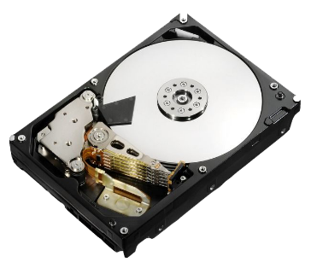 | CPU
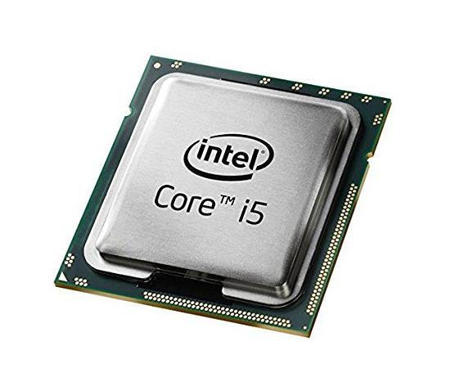  CPU | Hard Disk
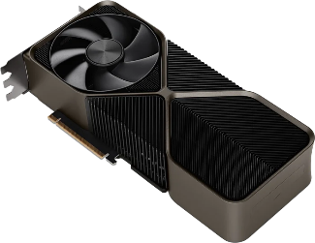 | RAM
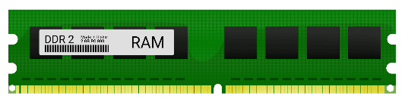 | GPU
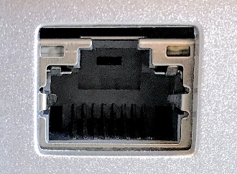 | Ethernet Port

Q2: Choose the correct answer from the following:
Computer | Ethernet Cable
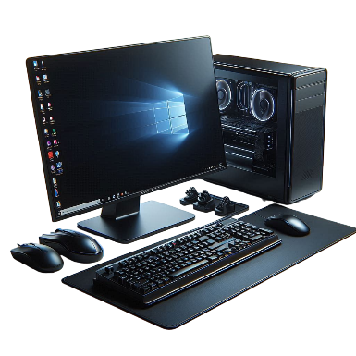 | (………………..)  Computer
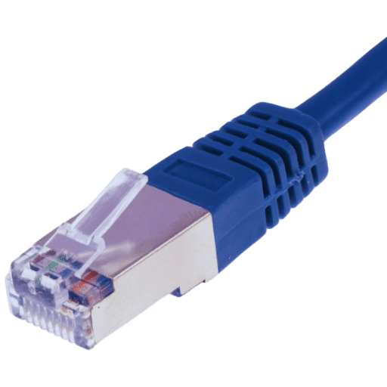 | (……………………..)  Ethernet Cable

Q3: Put (✔) or (✘):
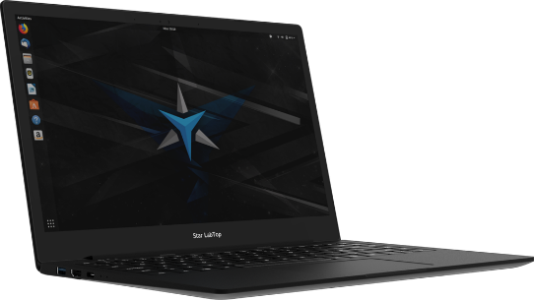 | Laptop  ✔ | (………………………)
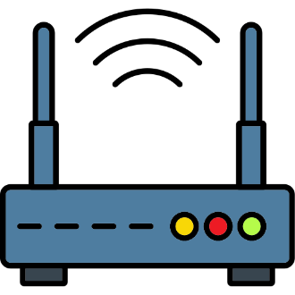 | Router | (………………………)  ✔
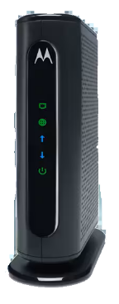 | Modems | (………………………)  ✔
Good Luck

